* GitHub repository for project **MSA**: [cohuynhhuu/sd2990_msa (github.com)](https://github.com/cohuynhhuu/sd2990_msa)
* GitHub repository for project **Azure Infrastructure**: [cohuynhhuu/sd2990_azure_infrastructure (github.com)](https://github.com/cohuynhhuu/sd2990_azure_infrastructure)

**Provisioning Infrastructure by Terraform:**

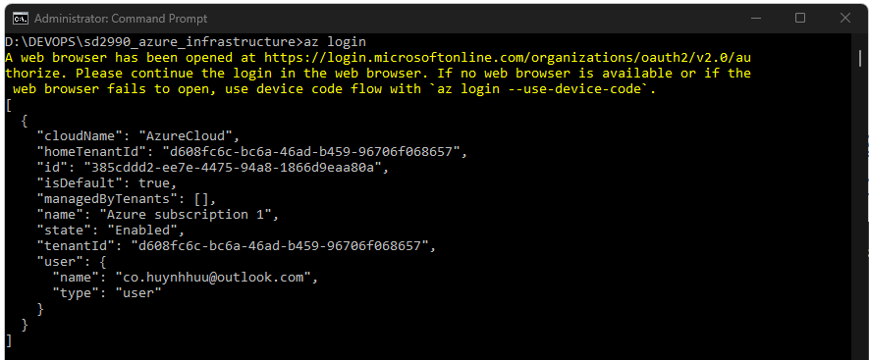

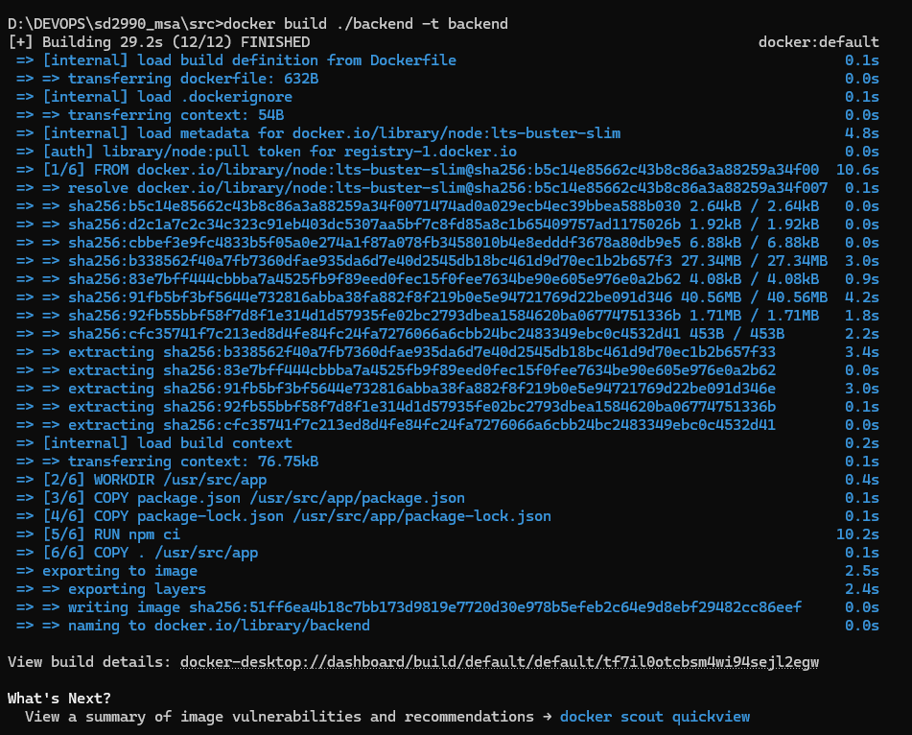

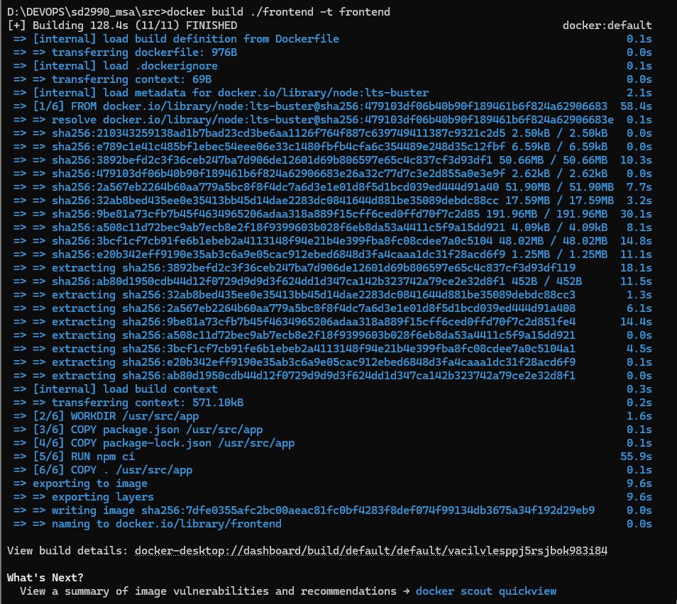

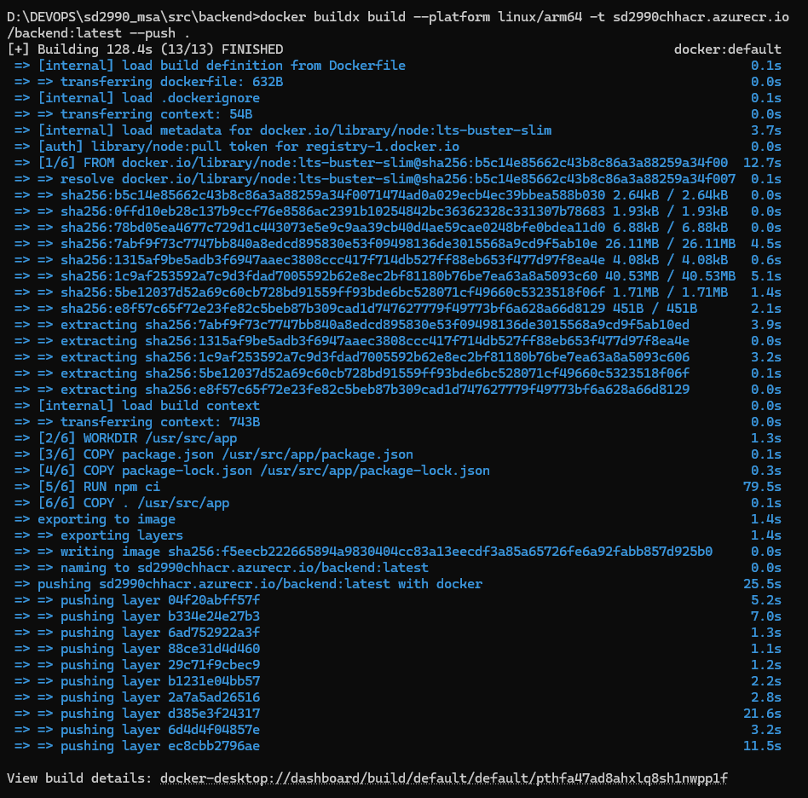

Still having issue and trying to fix asap:

* ##[error]No hosted parallelism has been purchased or granted. To request a free parallelism grant, please fill out the following form https://aka.ms/azpipelines-parallelism-request

THANK YOU!